 Umpire’s Report Form – World Para Athletics Rules (March 2024)

EVENT……………………………………… (Heat No… / SF … /Final) UMPIRING POSITION No:…………..
Competitor Number: ………. Lane/Hip No:…… Umpire’s Name:……………..…..……. Lap No:……. Umpire’s Signature:…………….……..

Rule No: | Description:
2.13.5 | Unsporting manner ☐ improper conduct ☐ (Give full details on reverse) Referee note: YC/YRC/RC.
5.4 (c) | Athlete and/or guide failed to complete with bona fide effort (Give full details on reverse)
6.15.3 | Tether breaks during race
7.3 (a) | Pacing: by persons not in race ☐ by lapped athletes ☐ by any technical device ☐
7.3 (f) | Receiving physical assistance from other athletes making forward progression
7.9.5 | Failure to comply with tether rule: releasing tether before finish ☐ shortening tether ☐
7.10.4 | Failure to comply with rule 7.10: guide pushing athlete ☐ pulling athlete ☐ propelling athlete ☐ sling-shotting ☐ (Give details of when/where on reverse)
7.12.2 | Failure to exchange guide when declared
18.1 (b) | Jostling ☐ Obstruction ☐ by athlete or guide runner Impeded Athlete No............. (Give details on reverse)
18.2 (c) | (Races or part thereof in lanes) Ran ☐wheeled ☐ over left lane line completely for …… step(s)/push(es).  Ran ☐ wheeled ☐ on the line for 2 or more steps. Number of steps/pushes……
18.2 (d) | (Races not in lanes) Ran☐ wheeled ☐ over kerb or line marking inside border on bend for 2 or more steps/pushes No. of steps/pushes:…  Ran ☐ wheeled ☐ on kerb or line marking inside border on a bend for 2 or more steps. No. of steps/pushes:…
18.5 (c) | (Races or part thereof in lanes) Ran ☐ wheeled ☐ on left lane line once  Referee note: “L” applied for touching the line once: YES/NO  DQ 18.2 (c) applied for 2nd lane infringement in any round of same event: YES/NO
18.5 (d) | (Races not in lanes) Ran ☐ wheeled ☐ on or over kerb or line marking insider border for ONE step  Referee note: “L” applied for touching or stepping/wheeling over the kerb/line once (1st instance): YES/NO  DQ 18.2 (d) applied for 2nd lane infringement in any round of same event: YES/NO
18.3 | Propulsion of wheelchair other than by pushing on wheels or push-rims
18.4 | Obstruction in wheelchair and frame running races when overtaking another athlete
18.6 | Stepping ☐ Wheeling ☐ on inside of track at any point to gain material advantage (e.g. to escape from boxed position)
18.7 | Leaving the assigned lane before the breakline (…………. metres ☐ steps ☐ pushes ☐ )
18.9 | Continuing in the race after voluntarily leaving the track on Lap No......
19.4 | Guide finishes ahead of athlete (NOTE: DQ applied by Chief PFJ or by Track Referee if no PF)
 | Other Infringement/incident ☐ / More information ☐: details on reverse
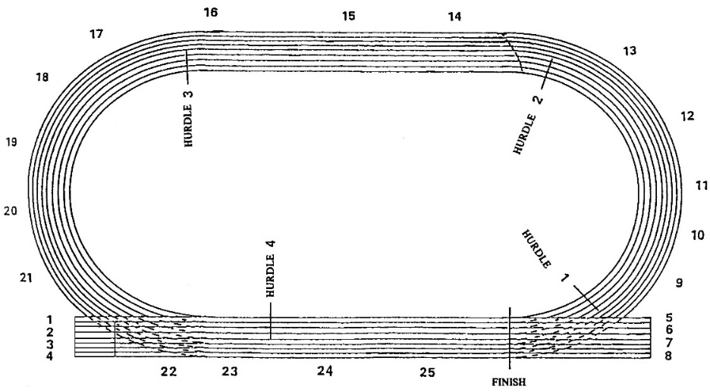
Please indicate on track plan the exact position of the infringement/incident

NOTE: Lane infringement “L” for wheelchairs/ frame runners:
Wheelchairs: Athlete is allowed 2 further pushes on the push rim from the first contact point on the left line to return to his/her lane before a DQ is applied. .
Frame Running: Athlete is allowed 2 further steps from the first contact point on the left line to leave it & return into lane before a DQ is applied.

