
Umpire’s Report Form: INDOOR RELAY

EVENT……………………………………… (Heat No… /Final)
Team No/Name: ……………..…..…... Lane/Hip No:……..
Take over 1 2 3 / Leg No. 1 2 3 4

UMPIRING POSITION No:…………..
Umpire’s Name:………………..………… Signature:…………….……..

Rule No: | Description:
TR 6.3 | Received assistance (Give full details on reverse)  Referee note: YC/YRC/RC Use rule TR 7.1 State appropriate subsection of TR 6.3 when informing PF
TR 7.1 | Unsporting manner ☐ improper conduct ☐ (Give full details on reverse)  Referee note: YC/YRC/RC. State reason when informing PF
TR 17.1.2 | Jostling ☐ Obstruction ☐ Impeded Team ............. (Give details on reverse)
TR 17.2.3 | (Races or part thereof in lanes) Ran over left lane line completely for …… step(s).  Ran on the line for 2 or more steps Number of steps……
TR 17.2.4 | (Races not in lanes)  Ran over kerb or line marking inside border on bend for 2 or more steps. Number of steps:….  Ran on kerb or line marking inside border on a bend for 2 or more steps. Number of steps:…
TR 17.3.2 | Lane infringement on straight with material advantage ☐  Lane infringement on outer line on bend with material advantage ☐
TR 17.3.3 | (Races or part thereof in lanes) Ran on left lane line once  Referee note: “L” applied for touching the line once: YES/NO  DQ 17.3.3 applied for 2nd infringement of this rule (not in same race): YES/NO
TR 17.3.4 | Ran on or over kerb or line marking insider border for ONE step  Referee note: “L” applied for touching/stepping over the kerb/line once: YES/NO  DQ 17.3.4 applied for 2nd infringement of this rule (not in same race): YES/NO
TR 17.6 | Continuing in the race after voluntarily leaving the track on Lap No......
TR 24.5 | Running / finishing the race without the baton ☐ Using gloves or substances on hand ☐
TR 24.6 | Fault recovering a dropped baton (Give details on reverse)
TR 24.7 | Passing the baton outside the takeover zone (early ☐ / late ☐ takeover)
TR 24.9 | Taking the baton from another team
TR 24.19 | Starting outside the takeover zone
TR 24.21 | Jostling ☐ or obstruction ☐ at takeover when not in lanes. Impeded Team ………  (Give details on reverse)
TR 44.6 | Leaving assigned lane before the breakline
TR 48.4 | Changing line-up order at takeover after being placed in position (4x200m, 4x400m or 4x800m)
 | Other Infringement/incident ☐ / More information ☐: details on reverse
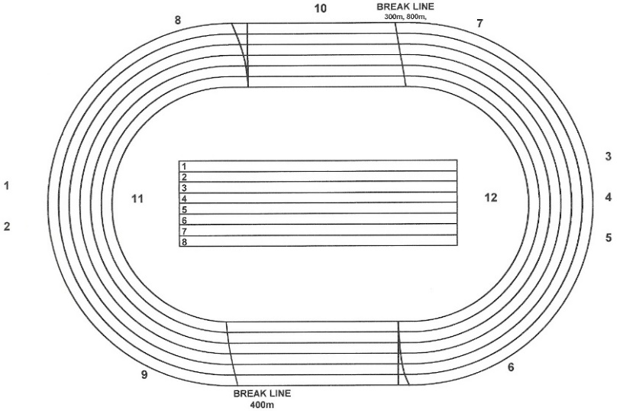
Please indicate on track plan the exact position of the infringement/incident

